The Black Death: The Medieval Plague Pandemic Through the Eyes of Ibn Battuta
0.2 – About this Module for Students

What you need to do now (before the first class):
- Read this “About this Module” document
- Gather your thoughts about what you already know about the Black Death (submit your notes to your Instructor before the first session)

Introduction

This module introduces you to what is currently known about the late medieval plague pandemic that struck much of Eurasia and North Africa in the 13th and 14th centuries. Plague, an infectious disease, is caused by a single-celled bacterium, Yersinia pestis. We know now that the late medieval pandemic was caused by strains of this organism that were not too far distant in their virulence from ones that still exist in the world today. This knowledge comes from a field called paleogenetics, which in recent years has radically transformed what we can know about the Black Death’s origins.

However, there is a lot more to a pandemic than just identifying the pathogen, the microorganism that causes it. How did it spread? Through what mechanisms or vectors? How did people react? Given that people in the Middle Ages did not have a means of seeing or understanding the microbial world (there were no microscopes then!), the historian is faced with the challenge of reconstructing a realm of existence that was literally invisible to people living at the time; only the end result of the pathogen—its crushing mortality—was visible to them. Thus, the historian must make sense of both the physical reality of the pandemic as modern science and historical investigations now enable us to reconstruct it, and the terror and chaos of the pandemic as the disease was experienced by human populations at the time.

Until recently, the story of the Black Death was told through European sources and events. In this module, in contrast, we will be surveying the Afro-Eurasian pandemic in its entirety, through the eyes of the 14th-century world traveler, Ibn Battuta (b. 1304, d. 1368/1369). In 1348-1350, he was returning to his home in Morocco from his 24 year sojourn in the Middle East and Asia. These are exactly the years when the Black Death—the Great Mortality or Great Plague, as it was called—struck the western Mongol world, Europe, and North Africa. The disease was also present in China, and it is possible that Ibn Battuta heard of recent outbreaks there, too.

What Ibn Battuta could not have known, however, was that plague had likely already started its transcontinental spread more than a century earlier. That is the story that scientific investigations, combined with a wider pool of documentary and archaeological sources, now allows us to see. The late medieval dissemination of plague seems to have struck China in the early 13th century. It probably reached Baghdad in 1258. New evidence suggests it had even reached western Europe around the time Ibn Battuta was born in the early 14th century. What Ibn Battuta was seeing and hearing about in 1348-1350 would have been new eruptions of a disease that had already embedded itself into rodent populations across two continents. How did it do that? Why was the disease able to persist in these regions for the next 400-500 years?

New investigative analyses still in formation have made possible a fuller understanding of the geographical breadth of the pandemic and its deeper chronological roots, with on-going debates within and between investigative fields. But having some understanding of this greatest of pandemics, even if some of the conclusions are tentative, is vital because we still live in a world of pandemics.

To approach a phenomenon as large as a pandemic covering two continents, we will look at four episodes, seen through several investigative methods. These allow us both to reconstruct elements of the experience of plague in Ibn Battuta’s world and that of his contemporaries, and to learn something of the new methods being used today to assemble the material history of the past, right down to its microbial foundations. That expanded sense of the pandemic—both its geographic extent and its timeframe—prompts us to revisit certain key aspects of our narratives about the causes of the pandemic itself and human responses to it.

The episodes and places we’ll be looking at help us create a “global” frame of analysis, putting the pan- in “pandemic.” They also allow us to consider how different methods and approaches contribute to our knowledge. They are as follows:

- Lesson 1: the construction of Black Death narratives—that is, the stories we have inherited; this also allows us to see why new information coming from the sciences has been transformative
- Lesson 2: Ibn Battuta’s perception of the spread of the Black Death through the Middle Eastern cities of the eastern Mediterranean
- Lesson 3: how older narratives of the Black Death have continued to shape investigations even in the genetics age, and why that’s a problem; why the discovery of the so-called “Big Bang” in plague history has expanded our chronology
- Lesson 4: the circumstances leading up to the persecution of minority communities in Europe

Woven in between these particular examples will be more general finds that allow us to create a “scalar” analysis of the pandemic—that is, an idea of how various component elements (climate, bacteria, insect vectors, intermediate animal hosts, and finally humans themselves) came together to create not simply the “perfect storm” of peak mortality in the late 1340s, but also transformed whole landscapes that could allow plague to persist for centuries thereafter. Here is a diagram to help you keep in mind the notion of “scale” as it can be applied to pandemics:

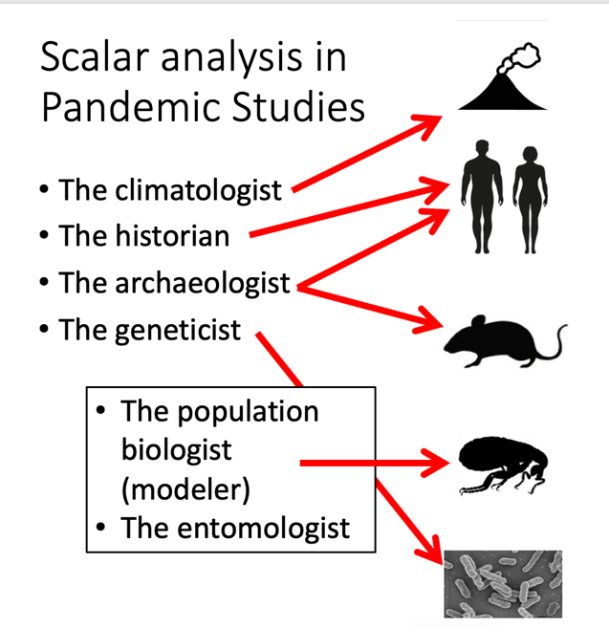

In all of this, we will remain focused on two kinds of questions:

- How did this pandemic happen? What caused a disease that had existed in isolated rodent populations to erupt into a devastating human pandemic? By what mechanisms was it able to reach so many new landscapes?
- How did different populations (all of them unaware of the biological causes of such mass sickness and death) understand and respond to the catastrophe visited upon them? If the disease was everywhere the same, why did reactions often differ drastically?

Pandemic thinking

Because a pandemic is by nature “global,” the techniques of global history are particularly useful to allow us to work simultaneously at various scales and also to compare different cultural settings. For this module, the most important technique of global history is what’s called “thinking at scale.” We are surveying the history of a phenomenon that involves a single-celled bacterium that spread across the world’s two largest continents (Eurasia and Africa) and affected millions of people, partly under the influence of global climate changes. We need a framework of analysis, therefore, that can help us think BIG and SMALL at the same time. That’s what scalar analysis can do. Plague in particular is best studied from this perspective. As seen in the diagram above, as a rodent disease that only occasionally spills over into human populations, we need to continually think about all the different scales of change that need to be active to get any disease activity in humans. We usually need to think at more than one “scale” at a time, for example, the evolution of the bacterium in the context of human long-distance trade in grain.

We also need a framework of analysis that can allow us to compare historical events in vastly different cultures, with not only different languages but different cultural traditions for conceiving of illness and death. There was no World Health Organization in the Middle Ages, no international (or even national) systems for gathering information on diseases. Most societies at the time had no standardized methods for counting the dead. In order to do global history of the medieval pandemic, therefore, we need to think about the global (climatic), regional (long-distance trade), local (political), faunal (rodents), and bacterial elements.

The result is “pandemic thinking”: ways to take in the enormity of a particular kind of rare crisis where human populations across vast landscapes are all having to cope with life-or-death threats brought on by the natural world. This is a world we still live in.

Using what you know

In this module, we will cultivate a special approach to learning. Whatever your background training, you already know something about the Black Death. You heard about it in middle school; you’ve seen depictions in movies; maybe you play video games that reference it. You have also lived through a pandemic of your own. Many of the things you’ll encounter in this module will challenge what you think you already know. That’s okay! You will get the most out of this dive into pandemic thinking if you train yourself to ask: “Why do I believe this? Where is this assumption coming from? And what’s different about the information I’m being presented with now?”

Time commitments

This module was designed to require roughly six hours of class time over two weeks and about twice that amount preparing for class. If it takes significantly more than that, you should talk to your instructor. It may be that they can offer some useful guidance to you, or it may be that they can offer some guidance to the History for the 21st Century project to adjust the lesson for future students.

Format

This module uses an approach to reconstructing the past that combines elements of the written record with material remains of a profound physical crisis endured in repeated waves in Afro-Eurasia in the late Middle Ages. To reconstruct human experiences of the pandemic, we will read excerpts from texts written during the period we are studying (primary sources). To reconstruct the biological event, we will see what kinds of stories can be retrieved from physical remains of individuals afflicted by the pandemic. These physical remains in some cases yield genetic data of organisms involved in historical pandemics (DNA). Studying the cemeteries themselves yields certain information about how bodies were treated after death and ways that societies attempted to maintain order in the midst of chaos. By combining these approaches, you will be able to see how historians construct their understandings about the past, a process that is continually on-going.

Learning goals

By the end of this module, you will be able to:

- Describe what “the Black Death” was and explain the geographical and chronological extent of the Second Plague Pandemic
- Explain how historians of medicine reconstruct the history of infectious diseases and the types of evidence they use
- Understand how knowledge from historians, geneticists, and archeologists together is necessary to understand the spread of and rection to the Second Plague Pandemic
- Summarize why different cultural traditions have different understandings of disease, and therefore respond differently to epidemic threats

Schedule and Readings

Topic | Readings before the class | In-class activities
Before the module | - About this module | - Summarize what you know about the Black Death
Lesson 1: Ibn Battuta’s world | - Reading 1: Ibn Battuta’s world | - Defining what you already know about pandemics  - Getting to know plague: a primer  - Asking questions about the history of the Second Plague Pandemic
Lesson 2: What Ibn Battuta saw: Damascus and Cairo | - Reading 2: What Ibn Battuta saw: Damascus and Cairo | - Reconstruct Ibn Battuta’s itinerary during the Second Plague Pandemic  - Explore the ethics of studying the history of human diseases  - Understand how and why people in Islamic societies responded to the Second Plague Pandemic
Lesson 3: What Ibn Battuta didn’t see: Plague’s emergence and focalizations | - Reading 3: What Ibn Battuta didn’t see: Plague’s emergence and focalizations | - Understanding how prevalent ideas about the Black Death were formed  - Understanding how paleogenetics helps us understand the Second Plague Pandemic’s spread
Lesson 4: Accusation and persecution: The fate of Europe’s minorities | - Reading 4: Accusation and persecution: The fate of Europe’s minorities | - Compare evidence from archeological sites of the Second Plague Pandemic  - Understand how and why some responses to the Second Plague Pandemic included violence toward minorities

Why do we talk about “Eurasia” instead of “Europe” and “Asia”? Because when you look at a map, you see that there are no absolute physical boundaries separating these land masses. When we’re talking about a disease being transported by wild animals, that lack of physical boundaries is important.

